1957 | 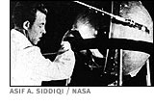  October 4: The Soviet Union launches Sputnik 1 into earth orbit. The first man-made satellite passes overhead, making one revolution every 90 minutes.  October 5: The Soviet daily newspaper Pravda mentions Sputnik in a short piece at the bottom of page one. When bold headlines and major stories run in British and American newspapers, the U.S.S.R. realizes that the Sputnik program is a huge propaganda tool.  November 3: Sputnik 2 carries Laika, a female dog, into space. Although the satellite will remain in orbit for 162 days, scientists plan to put Laika to sleep after a week because there is no way to return her to Earth safely. Later reports indicate that Laika died soon after liftoff, from stress and high temperatures inside the capsule.  The American press nicknames the second Soviet satellite "Muttnik" because of its biological payload.
1958 | 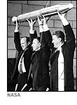  January 31: Explorer 1, the first American satellite, enters orbit around Earth.  July: President Dwight Eisenhower signs the National Aeronautics and Space Act of 1958 into law, establishing NASA. The American program had been delayed in part because Eisenhower insisted that the space program should be a non-military operation, and that it should not reconfigure defense missiles for space exploration.  December 6: Pioneer 3, an American unmanned satellite, fails to reach the moon, but discovers a second radiation belt around the Earth.
1959 | 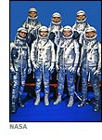  January: Luna 1 launches from the Soviet Union towards the moon but misses its target. Soviet lunar probes had been launched in 1958 but not announced to the public or acknowledged. This set a pattern for the Soviet space program: missions were not announced until they could be hailed as successes.  March 3: The U.S. sends the unmanned Pioneer 4 to the moon in the first American lunar flyby.  April 9: The newly formed National Aeronautics and Space Administration introduces the first seven astronauts to the world. Without yet performing a task, they are instantly hailed and embraced as heroes by the American public.  May 28: NASA launches two monkeys from Cape Canaveral and successfully recovers them in the Atlantic Ocean.  September: The Soviets' Luna 2 successfully crash-lands on the moon, becoming the first man-made object to reach another planetary body.  October: Luna 3 flies around the moon, taking the first photographs of the far side of the moon. Two more Soviet launches the following year will not achieve proper flight paths. Information about them will be suppressed.
1961 | 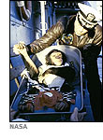  Jan 31: Ham, a chimpanzee, survives a sub-orbital flight on an American mission, Mercury 2.  The American press pokes fun at American astronauts for doing a job that could be accomplished by a monkey.  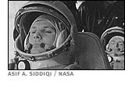  April 12: Vostok 1 carries Soviet cosmonaut Yuri Gagarin into orbit; he is the first human in space. The Soviets refer to Gagarin as a "cosmonaut." The Americans had considered "cosmonaut" as a title for their space travelers but had already settled on "astronaut."  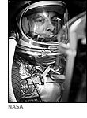  May 2: Alan Shepard commands Freedom 7 on the first Mercury mission, becoming the first American in space. His ballistic trajectory during the 15-minute flight takes him to a maximum height of 116.5 statute miles.  NASA announces, "The astronaut reports that he is A-OK," introducing a new phrase into the American lexicon.  May 25: President John F. Kennedy, in his first State of the Union address, accelerates the space program and sets as a goal, a moon landing within the decade.  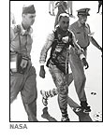  July 21: American astronaut Gus Grissom's sub-orbital flight is marred when, after splashdown, the hatch of his capsule blows open and the capsule sinks. The blown hatch cannot be replicated later in hardware tests, but the emergency hatch detonator requires a strong hammer blow by the fist and Grissom doesn't show the bruise that would accompany such action. Despite scarce evidence for either theory about what happened, the press puts the blame squarely on the astronaut.
1962 | 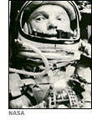  February 20: John Glenn orbits the Earth three times, becoming the first American in orbit. Hailed as a hero, he will later leave the space program to enter politics. Eventually he will be elected to the U.S. Senate from Ohio.
1963 | 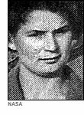  June 6: A Russian, Valentina Tereshkova, becomes the first woman in space.  The American program, which has drawn astronauts from active duty military pilots, employs no female astronauts.
1964 | October 12: V. M. Komarov, K. P. Feoktistov and B. B. Yegorov all fly on Voskhod 1, the first mission to send multiple men into space.
1965 | 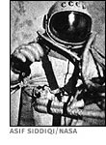  March 18: Voskhod 2 carries Pavel Belyayev and Alexei Leonov into orbit. Leonov leaves the spacecraft on the first "spacewalk."  March 23: Gus Grissom and John Young pilot the first two-man Gemini spacecraft, Gemini 3, named the Molly Brown in recognition of Grissom's Mercury splashdown.  The Gemini program will solve many of the problems that must be overcome for a lunar landing mission.  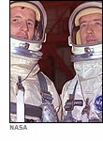  June 3-7: On Gemini 4, a particularly strong astronaut, Edward White II, exits his vehicle and performs the first American space walk. The ease with which he maneuvers will not be easily replicated by subsequent astronauts who attempt to perform mechanical tasks on space walks.  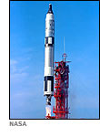  December 4-18: American astronauts Frank Borman and Jim Lovell fly Gemini 7 for fourteen days, setting an endurance record that will remain unbroken until 1970.  December 15-16: Wally Schirra and Thomas Stafford fly Gemini 6 within a few feet of Borman and Lovell in Gemini 7, for the first true rendezvous in space.

1966 | January: Sergei Korolov, the driving force behind the Soviet space program, dies. His successors will not wield the same political influence as he did, contributing to emerging problems in the Soviet program.  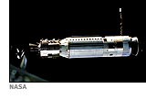  March 16: Americans Neil Armstrong and David Scott couple Gemini 8 to an unmanned Agena vehicle, docking two spacecraft together for the first time. Shortly after this feat, Gemini 8 experiences a stuck thruster, causing the craft to tumble wildly, and the rest of the mission is aborted.  Following reports of Gemini 8's problems, the Soviet Union reveals that their Voskhod 2 mission the previous March had landed far off course and the astronauts were stranded in a snowy forest for a day before they could be recovered.  March 31: Luna 10 launches from the Soviet Union. The unmanned probe will achieve lunar orbit -- the first object to do so -- and send information about the moon back to Earth.  May 30: The unmanned American Surveyor 1 craft lands on the moon and transmits photographs and other data back to Earth.  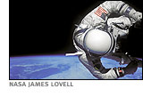  November 11-15: On the last Gemini flight, Jim Lovell and Edwin "Buzz" Aldrin dock with an Agena and Aldrin makes three space walks, performing a number of physical tasks without undue effort.
1967 | 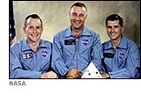  January 27: A fire during routine testing of the Apollo spacecraft kills three astronauts -- Gus Grissom, Ed White and Roger Chafee -- in their capsule.  The Russians send their condolences to the families of the astronauts.  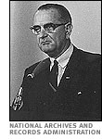  On the same date, President Lyndon Johnson and counterparts in London and Moscow sign the "Treaty on Principles Governing the Activities of States in the Exploration and Use of Outer Space." Signatories agree, among other points, that outer space will remain demilitarized, no territorial claims on Earth orbit or any planetary bodies will be made and that astronauts or cosmonauts who find themselves landing off course will be returned to their home countries.  http://www.unoosa.org/oosa/en/ourwork/spacelaw/treaties.html  April 23: Vladimir Komarov commands Soyuz 1. On its descent, the parachute becomes tangled and Soyuz 1 slams into the ground at high speed, killing Komarov. It is the first death to occur during a space flight.
1968 | September 14: The Soviet Union sends Zond 5 around the moon and back to Earth in an unmanned test of their circumlunar spacecraft.  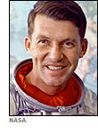  October 11-12: After extensive redesign work, Apollo 7, commanded by Wally Schirra (the only astronaut to command Mercury, Gemini and Apollo missions) enters Earth orbit in the first test of the spacecraft.  October: The Soviets launch the unmanned Soyuz 2. A day later Soyuz 3, piloted by Georgii Beregovoi, launches and completes a rendezvous with Soyuz 2 in orbit.  November 10: Zond 6 follows its predecessor's trajectory around the moon and returns with a "skip" reentry, bouncing once off the Earth's atmosphere to reduce the G-forces acting upon the contents. Two more Zond flights will follow in 1969 but they will all be unmanned.  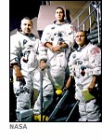  December 21-27: Apollo 8 completes the first manned orbit of the moon. Frank Borman commands the mission, Jim Lovell acts as navigator and William Anders is photographer and geological observer.
1969 | March 3-13: The American Apollo 9 mission tests the Lunar Module for the first time, in Earth orbit.  May 18-26: Apollo 10 utilizes both the command-service module and the Lunar Module around the moon. Americans Tom Stafford and Gene Cernan descend to within 50,000’ of the surface of the moon.  July 16: Apollo 11 begins its mission to the moon.  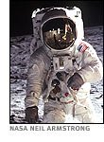  July 20: Americans Neil Armstrong and Buzz Aldrin become the first men to walk on the moon. They then rendezvous with Michael Collins in the command module for the return to Earth.  July 24: Apollo 11 returns to Earth safely.  November 14-24: Apollo 12 lands on the moon. Pete Conrad and Alan Bean collect lunar samples, as well as parts of the unmanned Surveyor 3, another American spacecraft that had landed on the moon in April 1967.
1970 | 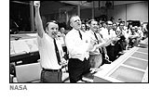  April 11-17: En route to the moon, oxygen tanks explode on Apollo 13's command-service module. Through quick thinking from the crew and mission control, astronauts Jim Lovell, Jack Swigert and Fred Haise manage to survive in the Lunar Module until just before reentry to the Earth's atmosphere when they return to the command-service module and land safely.
1971 | January 31-February 9: Alan Shepard, the first American in space, commands Apollo 14 for the third lunar landing, on February 5.  July 26-August 7: Apollo 15 lands on the moon with a four-wheel drive lunar rover.
1972 | 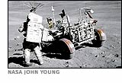  April 16-27: Apollo 16 lands on the moon and travels almost 17 miles with the lunar rover.  December 7-19: Gene Cernan and Harrison Schmitt become the last men to walk on the moon in the twentieth century. They remain on the moon for three days (75 hours). Schmitt is the first scientist-astronaut to land on the moon.
1975 | 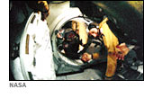  July 15-24: The last Apollo mission carries Donald K. "Deke" Slayton into space with Tom Stafford and Vance Brand (Slayton, one of the original Mercury astronauts, had not previously flown in space due to a heart fibrillation). In orbit, they dock with a Soviet Soyuz spacecraft. The mission proves the compatibility of the two space programs and paves the way for future collaborations and rescue missions.

